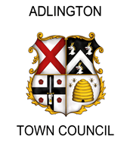
ADLINGTON TOWN COUNCIL
2022 Adlington Town Council Community Awards application

Please complete and return this form to the Clerk by Monday 31st January 2022 with:
- A copy of the most recent audited accounts for the organisation
- A current financial summary and/or Bank Statement

Organisation Name
Your name, position &
contact number

Brief summary of activities of the organisation
Amount of funding requested, and what proportion of the total cost this represents

What will this money be used for?
Please include full costings; the amount requested; your evidence of the need for the project; who will benefit from it; how and when it will be delivered; and what impact or difference will it make?

Postal Address – any grant offered will be paid by cheque to be posted to your or your organisation’s address

Signed ________________________________________________

Please check – most recent audited accounts and current financial summary are included

